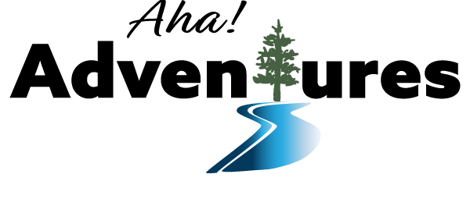
Gear List
- Waterproof barrel with backpack or drybag backpack to store your personal items it (we can supply)
- Small drybag or waterproof box for things you need access to during the day (we can supply)
- You will be responsible for your own lunches
- Breakfast and Suppers will be shared among the group (cooking groups and schedule will be determined during the pre-trip zoom meeting)
Clothing  Avoid cotton if possible – bring extras if they are cotton  - Sunhat and sunglasses  - Toque/mitts/buff  - Long underwear: top and bottom  - Shirts (1 short sleeve, 1 long sleeve per week)  - 1 light wool or synthetic sweater  - 1 fleece or light down jacket  - Rain jacket (with a hood)  - Rain pants  - Shorts (1 pair per week)  - Swimsuit  - Quick-dry pants (no jeans!!! – 1 pair for day, 1 pair for evening)  - Wool/synthetic socks (2 - 3 per week)  - Quick dry underwear  - Camp & walking shoes (close-toed)  - Wet shoes (sport sandals, old runners- no flip flops!!!)  - Stuff sacks for organizing  - Zip loc bags for extra waterproofing  - Garbage bags (5)  - Clothes line  For Cold Water/Weather Conditions or late/early season trips  - Paddling/neoprene gloves  - Neoprene booties/rubber boots  - Paddling drypants with feet (optional)  - Warmer compressible sleeping bag (-5 to -10) | Personal Gear  - Sleeping pad/ Thermarest  - Compressible sleeping bag  - Bug spray and sunscreen  - Lip balm  - Toiletries  - Hand sanitizer/wipes  - Toothbrush/toothpaste  - Toilet paper in Ziploc (estimate 1 roll/week/person)  - Brown paper bags for toilet paper disposal  - Personal medications  - Personal first aid kit  - Quick-dry towel  - Pocket knife  - Lighter  - Flashlight/ headlamp  - Water bottle (min. 1 litre)  - Dry bag for day use  - Backpacking style tent with full rainfly  Optional Gear  - Camera and waterproof case  - Camp Chair  - Binoculars  - Ear plugs  - Fishing gear and fishing license  - Book  - Cards or small travel games  - Hacky sack, Frisbee  - Bug jacket  - Journal/diary/pen  - Clothes - to be left in the van for trip home | Gear  Supplied by Aha! Adventures  - Drybags and barrels  - Canoes  - Paddles  - PFD’s  - Bailers  - Throwbags  - River Rescue Kit  - Helmets (if needed)  - Rope for tying in gear  - Canoe repair kit  - Maps  - First Aid Kit  - Satellite phone/ SPOT  - Camp tarps  - Stoves and fuel  - Pots  - Coffee pot/kettle  - Camp table  - Fry pan  - Shovel for latrine  - Cooking utensils  - Axe/saw  - Fire box  - Fire starter/lighter  - Dish soap/scrubbers  - Water filter  - Bear spray/bear bangers  Food  - Individual lunches  - Your assigned supper and breakfast  - Individual snacks  - Eating utensils/bowl/cup  - Hot beverages (tea, hot chocolate)

